AQA Computer Science A-Level

4.3.4 Searching algorithms

Past Paper Questions

June 2011 Comp 3

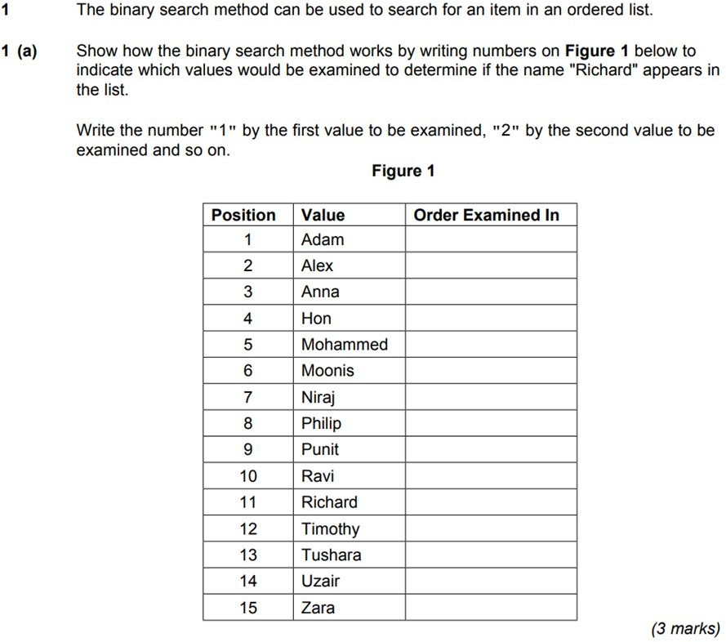

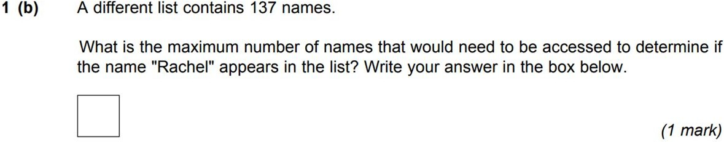

Specimen Paper 1

